**DAILY ONLINE ACTIVITIES SUMMARY**

|  |  |  |  |  |  |  |  |
| --- | --- | --- | --- | --- | --- | --- | --- |
| **Date:** | **19-05-2020** | | | | **Name:** | **Syed Hudaif Ibrahim** | |
| **Sem &**  **Sec** | **VI B** | | | | **USN:** | **4AL17CS104** | |
| **Online Test Summary** | | | | | | | |
| **Subject** | | **CGV IA Test** | | | | | |
| **Max. Marks** | | **60 Score 56** | | | | | |
| **Certification Course Summary** | | | | | | | |
| **Course** | **Full Stack Web Developer** | | | | | | |
| **Certificate Provider** | | | **Udemy** | **Duration** | | | **4 Weeks** |
| **Coding Challenges** | | | | | | | |
| **Problem Statement:**   1. We have a Letter or a word then we need add some letters to it and need to find out shortest palindrome 2. Write a C Program to check whether two strings are anagram or not. | | | | | | | |
| **Status:Completed** | | | | | | | |
| **Uploaded the report in Github** | | | | **Yes** | | | |
| **If yes Repository name** | | | | [https://github.com/SyedHudaif/Online-Codingupdates](https://github.com/SyedHudaif/Online-Coding-updates)  [https://github.com/SyedHudaif/Certificationcourse-updates](https://github.com/SyedHudaif/Certification-course-updates) | | | |
| **Uploaded the report in slack** | | | | **Yes** | | | |

**Online Test Details**

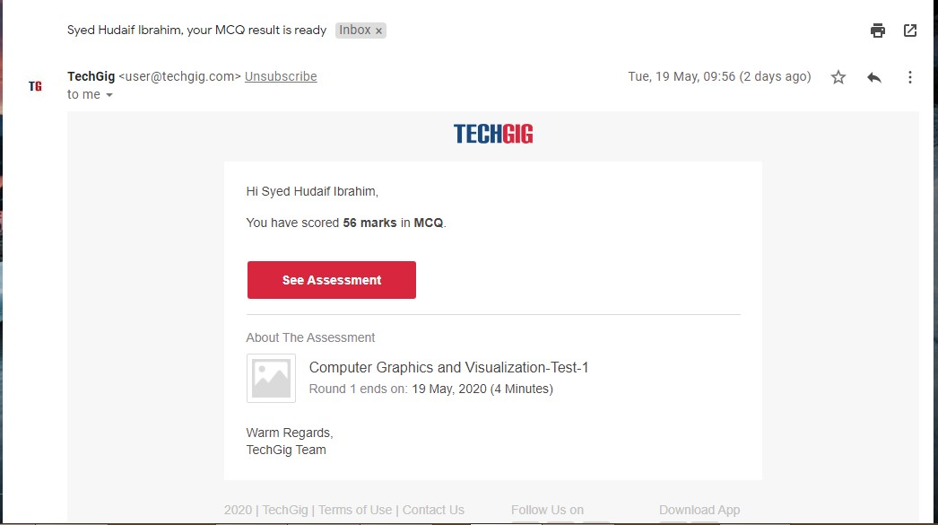

**Online Certification Details**

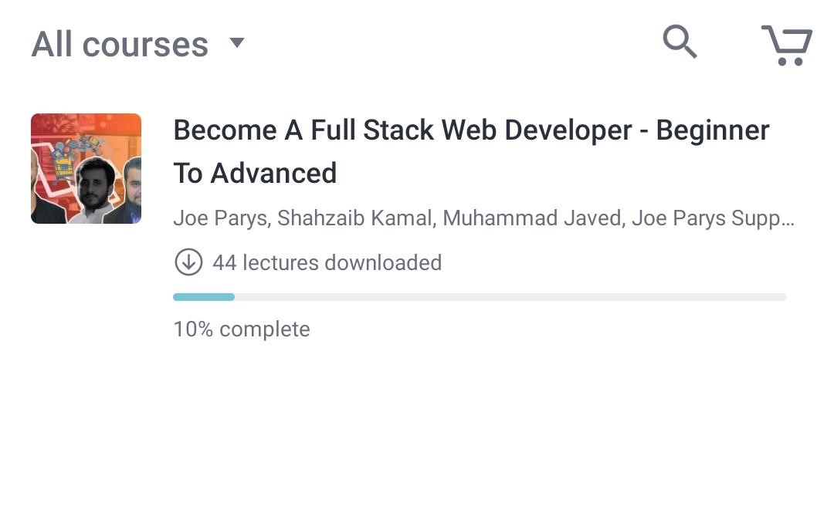

**Coding Challenge Details**

1.We have a Letter or a word then we need add some letters to it and need to find out shortest palindrome

For example we take "S": S will be the shortest palindrome string.

If we take "xyz": zyxyz will be the shortest palindrome string

So we need to add some characters to the given string or character and find out what will be the shortest palindrome string by using simple java program.

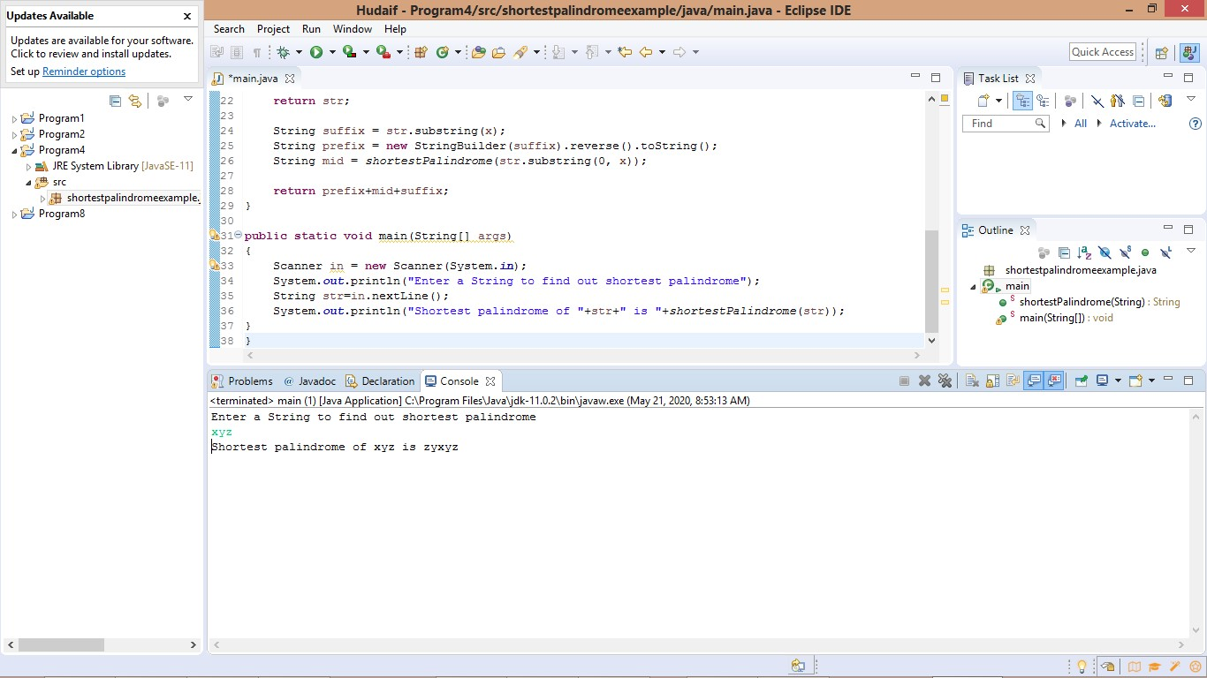

2. Write a C Program to check whether two strings are anagram or not.Hint: An Anagram of a string is another string that contains same characters, only the order of characters can be different.For example, "act" and "cat" are anagram of each other.

